* : 已有ID

+ : 新增

AFX_IDS_SAVE_DATA : MessageBox

IDS_DLG_MASS_ASSIGNIP_GUIDE : Dialog

IDS_SAVE_EX : 與原本ID衝突, 另外加上

Dialog::OnInitDialog()

vInitialLanguage()

LOADSTRING(str, IDS_CAM_NAME);

((CButton*)GetDlgItem(IDC_CHECK_EVENTMGR_QUERY_CAMERANAME))->SetWindowText(str);

2.  
SETITEMTEXT(IDC_STATIC_EVENTMGR_RULE_SOURCE, IDS_EVENT_SOURCE);

CView::OnCreate()

vInitialLanguage()

LOADSTRING(str, IDS_CAM_NAME);

((CButton*)GetDlgItem(IDC_CHECK_EVENTMGR_QUERY_CAMERANAME))->SetWindowText(str);

2.  
SETITEMTEXT(IDC_STATIC_EVENTMGR_RULE_SOURCE, IDS_EVENT_SOURCE);

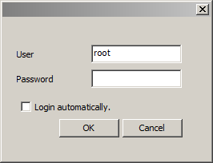

|  |  |  |  |
| --- | --- | --- | --- |
|  | ID | String (en) | String (zh-TW) |
| * | IDS_OK | OK | 確認 |
| * | IDS_CANCEL | Cancel | 取消 |

IDD_DLG_USER_LOGIN

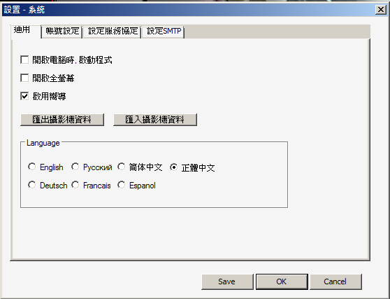

|  |  |  |  |  |
| --- | --- | --- | --- | --- |
|  | ID | String (en) | String (zh-TW) | 類似ID |
| * | IDS_OK | OK | 確認 |  |
| * | IDS_CANCEL | Cancel | 取消 |  |
| + | IDS_SAVE_EX | Save | 儲存 | IDS_SAVE |

IDD_SETTING_SYSTEM

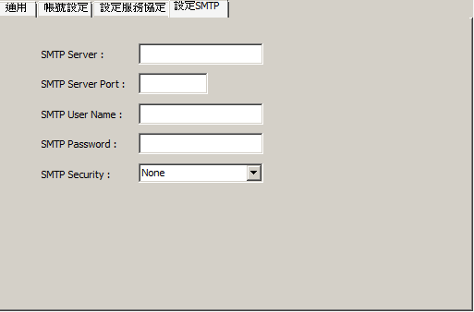

|  |  |  |  |
| --- | --- | --- | --- |
|  | ID | String (en) | String (zh-TW) |
| + | IDS_USERNAME | SMTP Username | 使用者名稱 |
| + | IDS_PASSWORD | SMTP Password | 密碼 |
| + | IDS_SMTP_SERVER | SMTP Server | SMTP 伺服器 |
| + | IDS_IP_PORT | SMTP Server Port | 連接埠 |
| + | IDS_CONNECT_SECURITY | SMTP Security | 加密連線類型 |

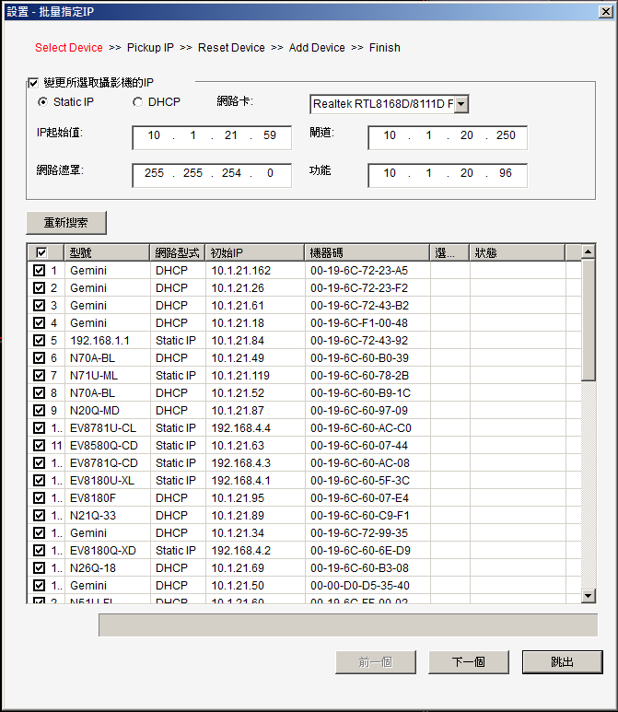

|  |  |  |  |
| --- | --- | --- | --- |
|  | ID | String (en) | String (zh-TW) |
| + | IDS_DLG_MASS_ASSIGNIP_GUIDE | Select Device >> Add Device >> Finish | 選擇裝置 >> 加入裝置 >> 完成 |
| + | IDS_DLG_MASS_ASSIGNIP_GUIDE_ADV | Select Device >> Pickup IP >> Reset Device >> Add Device >> Finish | 選擇裝置 >> 更改 IP >> 重新搜索 >>加入裝置 >> 完成 |
|  |  |  |  |

IDD_DLG_MASS_ASSIGNIP

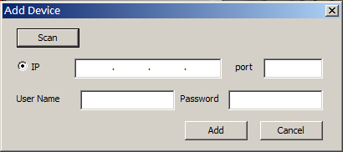

|  |  |  |  |  |
| --- | --- | --- | --- | --- |
|  | ID | String (en) | String (zh-TW) | 類似ID |
| + | IDS_DLG_ADD_DEV_TITLE | Add Device | 新增裝置 |  |
| + | IDS_USERNAME | Username | 使用者名稱 | IDC_USERNAME |
| + | IDS_PASSWORD | Password | 密碼 | IDC_PASSWORD |
| + | IDS_IP_ADDRESS | IP | IP 位址 |  |
| + | IDS_IP_PORT | Port | 連接埠 |  |
| * | IDS_OK | Add | 確認 |  |
| * | IDS_CANCEL | Cancel | 取消 |  |
|  |  |  |  |  |

IDD_ADDDEVICE_DIALOG

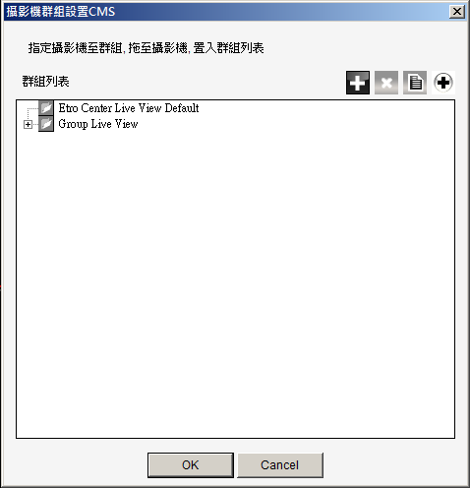

|  |  |  |  |
| --- | --- | --- | --- |
|  | ID | String (en) | String (zh-TW) |
| * | IDS_OK | OK | 確認 |
| * | IDS_CANCEL | Cancel | 取消 |

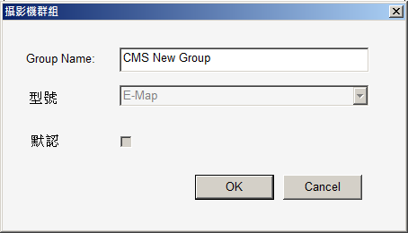

|  |  |  |  |
| --- | --- | --- | --- |
|  | ID | String (en) | String (zh-TW) |
| * | IDS_GROUP_NAME | Group Name | 群組名稱 |
| * | IDS_OK | OK | 確認 |
| * | IDS_CANCEL | Cancel | 取消 |

AfxMessageBox

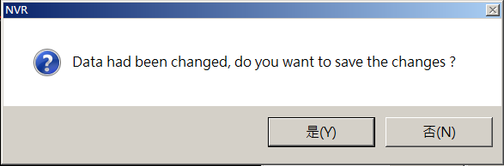

|  |  |  |
| --- | --- | --- |
|  | ID | String (zh-TW) |
| * | AFX_IDS_SAVE_DATA | 資料己經變更, 存儲變更? |
|  |  |  |
|  |  |  |

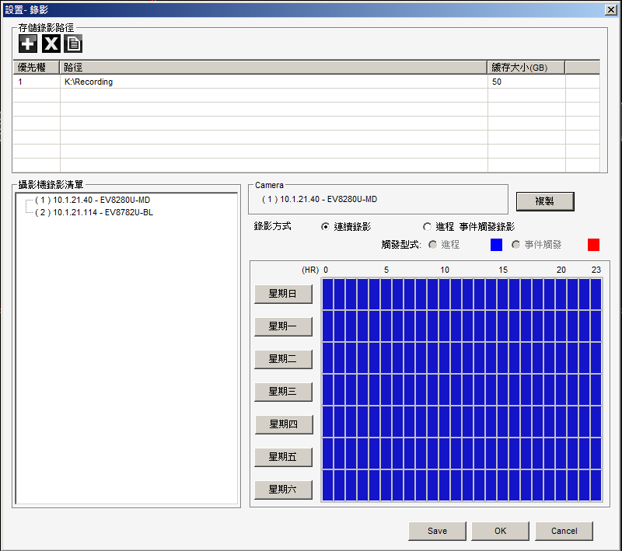

|  |  |  |  |  |
| --- | --- | --- | --- | --- |
|  | ID | String (en) | String (zh-TW) | 類似ID |
| * | IDS_OK | OK | 確認 |  |
| * | IDS_CANCEL | Cancel | 取消 |  |
| + | IDS_SAVE_EX | Save | 儲存 | IDS_SAVE |

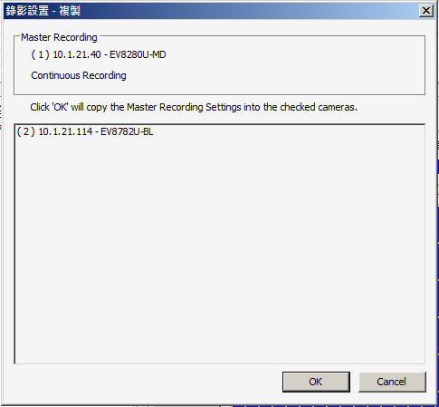

|  |  |  |  |
| --- | --- | --- | --- |
|  | ID | String (en) | String (zh-TW) |
| + | IDS_MASTER_RECORDING | Master Recording | 主錄影 |
| * | IDS_RADIO_CONTINUOUS | Continuous Recording | 連續錄影 |
| + | IDS_DLG_RECORDING_SETTING_HELP | Click 'OK' will copy the Master Recording Settings into the checked cameras. | 點擊“確定”複製主錄影的設置設定到選中的攝影機 |
| * | IDS_OK | OK | 確認 |
| * | IDS_CANCEL | Cancel | 取消 |

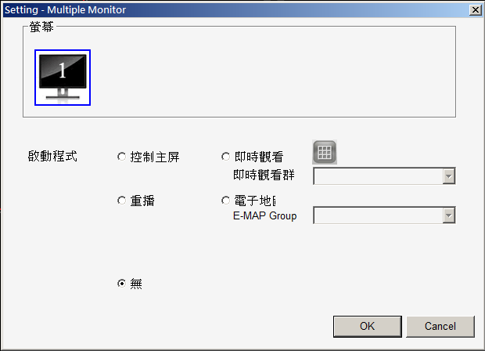

|  |  |  |  |
| --- | --- | --- | --- |
|  | ID | String (en) | String (zh-TW) |
| * | IDS_DLG_MULTIMONITOR | Seeting - Multiple Monitor | 設置 - 多個螢幕 |
| * | IDS_OK | OK | 確認 |
| * | IDS_CANCEL | Cancel | 取消 |
|  |  |  |  |
|  |  |  |  |

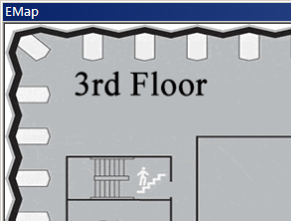

|  |  |  |  |
| --- | --- | --- | --- |
|  | ID | String (en) | String (zh-TW) |
| * | IDS_HINT_EMAP | EMap | 電子地圖 |
|  |  |  |  |
|  |  |  |  |
|  |  |  |  |
|  |  |  |  |

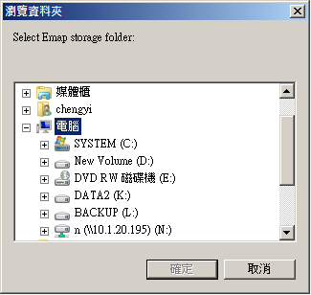

|  |  |  |  |
| --- | --- | --- | --- |
|  | ID | String (en) | String (zh-TW) |
| * | IDS_EMAP_FORLDER | Select Emap storage folder: | 選擇存放電子地圖資料夾 |
|  |  |  |  |
|  |  |  |  |
|  |  |  |  |
|  |  |  |  |

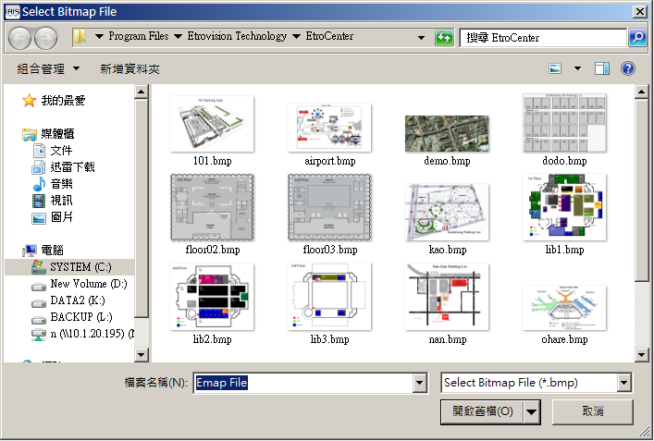

|  |  |  |  |
| --- | --- | --- | --- |
|  | ID | String (en) | String (zh-TW) |
| + | IDS_DLG_IMG_SAVE_TYPE_BMP | Select Emap storage folder: | 點陣圖 (*.bmp) |
| + | IDS_DLG_IMG_SAVE_TITLE | Select Bitmap File | 選擇圖片檔 |
|  |  |  |  |
|  |  |  |  |
|  |  |  |  |



|  |  |  |  |
| --- | --- | --- | --- |
|  | ID | String (en) | String (zh-TW) |
| * | IDS_OSD_TOOLTIP_SNAPSHOT | Snapshot | 抓拍 |
| * | IDS_OSD_TOOLTIP_FIX_RATIO | Fix Ratio | 固定比率 |
| * | IDS_OSD_TOOLTIP_SEND_AUDIO | Send Audio | 寄送音訊 |
| + | IDS_OSD_TOOLTIP_FIX_RATIO | Audio | 聲音 |
|  |  |  |  |

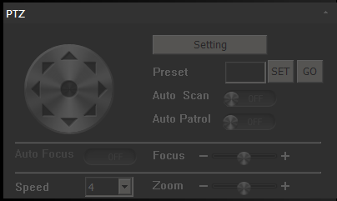

|  |  |  |  |
| --- | --- | --- | --- |
|  | ID | String (en) | String (zh-TW) |
| + | IDS_PTZ_SETTING | Setting | PTZ設定 |
| + | IDS_SET | SET | 設定 |
| + | IDS_GO | GO | 移動 |
| * | IDS_PTZ_AUTOSACN | Auto Scan | 巡航設定 |
| * | IDS_PTZ_PRESET | Preset | 預設點 |
| + | IDS_PTZ_AUTO_FOCUS | Auto Focus | 自動聚焦 |
| + | IDS_PTZ_FOCUS | Focus | 聚焦 |
| + | IDS_PTZ_SPEED | Speed | PTZ速度 |
| + | IDS_PTZ_ZOOM | Zoom | 縮放 |

IDD_DLG_PTZ

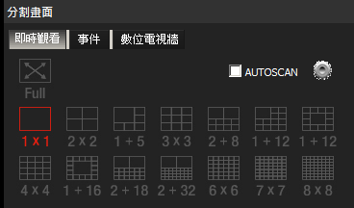

|  |  |  |  |
| --- | --- | --- | --- |
|  | ID | String (en) | String (zh-TW) |
| + | IDS_FULL_SCREEN | Full | 全螢幕 |
| + | IDS_PATROL | AUTOSCAN | 輪播 |
|  |  |  |  |
|  |  |  |  |
|  |  |  |  |

IDD_DLG_MATRIX

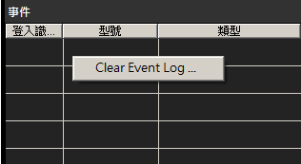

|  |  |  |  |
| --- | --- | --- | --- |
|  | ID | String (en) | String (zh-TW) |
| * | IDS_CLEAR_EVENT_LOG | Clear Event Log | 清除事件紀錄 |
|  |  |  |  |
|  |  |  |  |
|  |  |  |  |
|  |  |  |  |

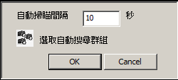

|  |  |  |  |
| --- | --- | --- | --- |
|  | ID | String (en) | String (zh-TW) |
| * | IDS_OK | OK | 確認 |
| * | IDS_CANCEL | Cancel | 取消 |

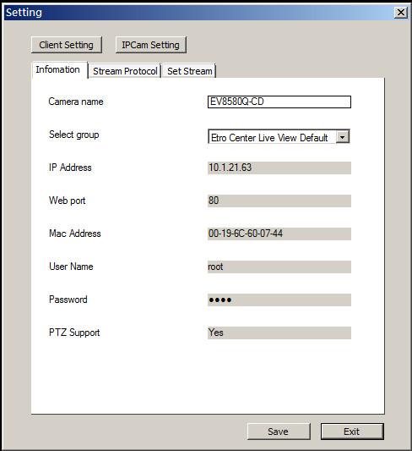 Lynn

|  |  |  |  |  |
| --- | --- | --- | --- | --- |
|  | ID | String (en) | String (zh-TW) | 類似ID |
| + | IDS_IPCAM_SETTING | Setting | 修改攝影機 |  |
| + | IDS_PROFILE | Client Setting | 設定檔 |  |
| + | IDS_IPCAM_PARAM | IPCam Setting | 攝影機參數 |  |
| + | IDS_INFORMATION | Infomation | 訊息 |  |
| + | IDS_STREAM_PROTOCOL | Stream protocol | 串流通訊協定 |  |
| + | IDS_STREAM_SETTING | Set | 串流設定 |  |
| + | IDS_CAMERA_NAME | Camera name | 攝影機名稱 |  |
| + | IDS_GROUP | Select group | 群組 | IDS_ADD_CAM_GROUPS_GROUP  IDS_HINT_GROUP_SETTING |
| + | IDS_IP_ADDRESS | IP | IP 位址 |  |
| + | IDS_IP_PORT | Web port | 連接埠 |  |
| + | IDS_MAC_ADDRESS | Mac address | Mac位址 |  |
| + | IDS_USERNAME | User name | 使用者名稱 |  |
| + | IDS_PASSWORD | Password | 密碼 |  |
| + | IDS_PTZ_SUPPORT | PTZ Support | 支援PTZ |  |
| * | IDS_OK | Save | 確認 |  |
| * | IDS_CANCEL | Exit | 取消 |  |

IDD_CONFIG_SETTING_DIALOG,

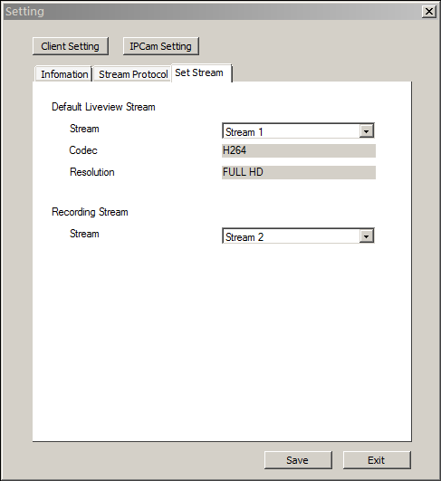 Lynn

|  |  |  |  |
| --- | --- | --- | --- |
|  | ID | String (en) | String (zh-TW) |
| + | IDS_DEFAULTLIVE_STREAM | Default Liveview Stream | 預設即時監看串流來源 |
| + | IDS_STREAM_SRC | Stream | 串流來源 |
| + | IDS_CODEC | codec | 編解碼器 |
| + | IDS_RESOLUTION | Resolution | 解析度 |
| + | IDS_RECORDING_STREAM | Recording Stream | 錄影影像來源 |
|  |  |  |  |
|  |  |  |  |
|  |  |  |  |
|  |  |  |  |

IDD_CONFIG_SETTING_DIALOG

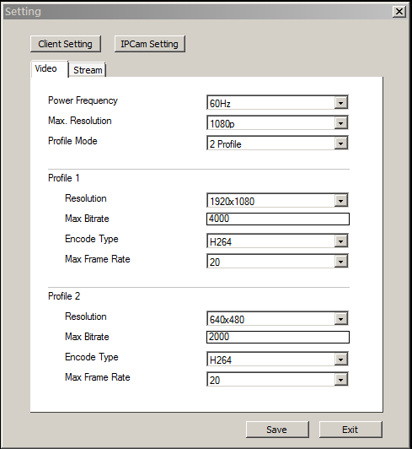 Lynn

|  |  |  |  |
| --- | --- | --- | --- |
|  | ID | String (en) | String (zh-TW) |
| + | IDS_VIDEO | Video | 影像 |
| + | IDS_STREAM | Stream | 串流 |
| + | IDS_POWER_FREQUENCY | Power frequency | 電源頻率 |
| + | IDS_MAX_RESOLUTION | Max. Resolution | 最大解析度 |
| + | IDS_STREAM_MODE | Profile Mode | 串流模式 |
| + | IDS_STREAM_1 | Profile 1 | 串流1 |
| + | IDS_STREAM_2 | Profile 2 | 串流2 |
| + | IDS_RESOLUTION | Resolution | 解析度 |
| + | IDS_MAX_BITRATE_KBPS | Max. Bitrate | 最大位元率(kbps) |
| + | IDS_ENCODE_TYPE | Encode Type | 編碼類型 |
| + | IDS_MAX_FRAME_RATE | Max Frame Rate | 幀率(bps) |

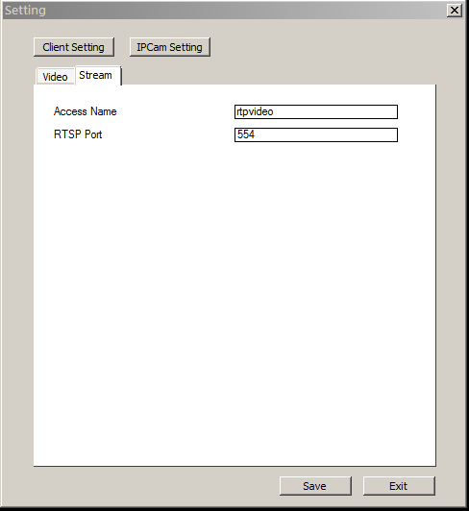 Lynn

|  |  |  |  |
| --- | --- | --- | --- |
|  | ID | String (en) | String (zh-TW) |
| + | IDS_ACCESS_NAME | Access name | 訪問名 |
| + | IDS_RTSP_PORT | RTSP Port | RTSP 埠 |
|  |  |  |  |
|  |  |  |  |
|  |  |  |  |
|  |  |  |  |
|  |  |  |  |
|  |  |  |  |
|  |  |  |  |

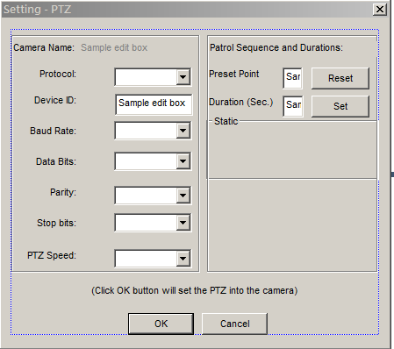

|  |  |  |  |
| --- | --- | --- | --- |
|  | ID | String (en) | String (zh-TW) |
| + | IDS_CAMERA_NAME | Camera Name | 攝影機名稱 |
| + | IDS_PROTOCOL | Protocol | 通訊協定 |
| + | IDS_BAUD_RATE | Baud Rate | 每秒位元數 (B) |
| + | IDS_DATA_BITS | Data Bits | 資料位元 (D) |
| + | IDS_PARITY | Parity | 同位檢查 (P) |
| + | IDS_STOP_BITS | Stop Bits | 停止位元 (S) |
| + | IDS_PTZ_SPEED | Speed | PTZ速度 |
| + | IDS_DLG_PTZ_SETTING_HELP | (Click OK button will set the PTZ into the camera) | (按下 '確認' 時, PTZ參數值將設定到攝影機) |
| * | IDS_PTZ_SPEED | Speed | PTZ速度 |
| + | IDS_ DLG_PTZ_SETTING_ PATROL_DURATION | Patrol Sequence and Duration | 巡航順序與停留時間 |
| * | IDS_PTZ_PRESET | Preset Point | 預設點 |
| + | IDS_DURATION_SEC | Duration (Sec.) | 停留時間 (秒) |
| + | IDS_PTZ_STATIC | Static | 靜止 |

IDD_DLG_PTZ_SETTING

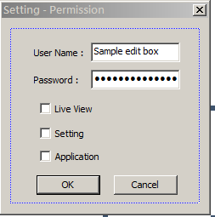

IDD_DLG_PERMISSION

|  |  |  |  |
| --- | --- | --- | --- |
|  | **ID** | **String (en)** | **String (zh-TW)** |
| * | IDS_USERNAME | User Name | 使用者名稱 |
| * | IDS_PASSWORD | Password | 密碼 |
| + | IDD_DLG_PERMISSION_TITLE | Setting - Permission | 設定 - 權限 |
| * | IDS_OK | OK | 確認 |
| * | IDS_CANCEL | Cancel | 取消 |
| + | IDS_LIVEVIEW | Live View | 即時監看 |
| + | IDS_SETTING | Setting | 設定 |
| + | IDS_APPLICATION | Application | 應用程式 |
|  |  |  |  |

DlgSettingLoginAuth.cpp

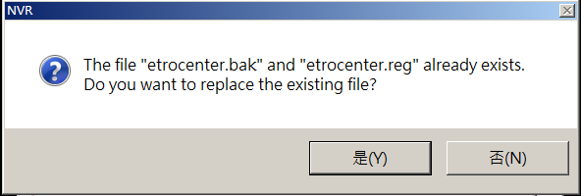

|  |  |  |  |
| --- | --- | --- | --- |
|  | **ID** | **String (en)** | **String (zh-TW)** |
| * | AFX_IDS_REPLACE_FILE_ONE | The file \"%s.%s\" and \"%s.%s\" already exists.\nDo you want to replace the existing file? | \"%s.%s\" 和 \"%s.%s\" 已存在，是否覆蓋檔案？ |
| * | AFX_IDS_REPLACE_FILE_TWO | The file \"%s.%s\" and \"%s.%s\" already exists.\nDo you want to replace the existing file? | \"%s.%s\" 已存在，是否覆蓋檔案？ |

DlgSettingSystem.cpp (653)

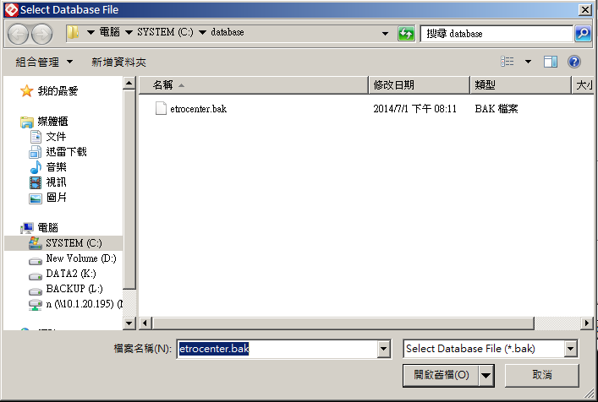

|  |  |  |  |
| --- | --- | --- | --- |
|  | **ID** | **String (en)** | **String (zh-TW)** |
| * | IDS_DLG_LOAD_DB_TITLE | Select Database File | 選擇資料庫 |
| * | IDS_DLG_LOAD_DB_TYPE_BAK | Select Database File (*.bak) | 資料庫 (*.bak) |

DlgSettingSystem.cpp (772)